CSA15 CLOUD COMPUTICSA15 CLOUD COMPUTING AND BIG DATA ANALYTICSNG AND BIG DATA ANALYTICS

Virtual systems

1.Demonstrate virtualization by Installing Type-2 Hypervisor in your device, create and configure VM image with a Host Operating system (Either Windows/Linux).

DATE:

AIM: To demonstrate virtualization by installing type-2 hypervisor in your device, create and configure VM image with a host operating system (either windows/linux).

PROCEDURE:

STEP 1:Dowload VMware workstation and installed as type 2 hypervisor. STEP2:Dowload ubuntu or tiny OS as iso image file.

STEP 3: In VMware workstation->create new VM.

STEP 4: Do the basic configuration settings.

STEP 5: Created tiny OS virtual machine.

STEP 6: Launch the VM. IMPLEMENTATION:

STEP 1:DOWLOAD VMWARE WORKSTATION AND INSTALLED AS TYPE 2 HYPERVISOR

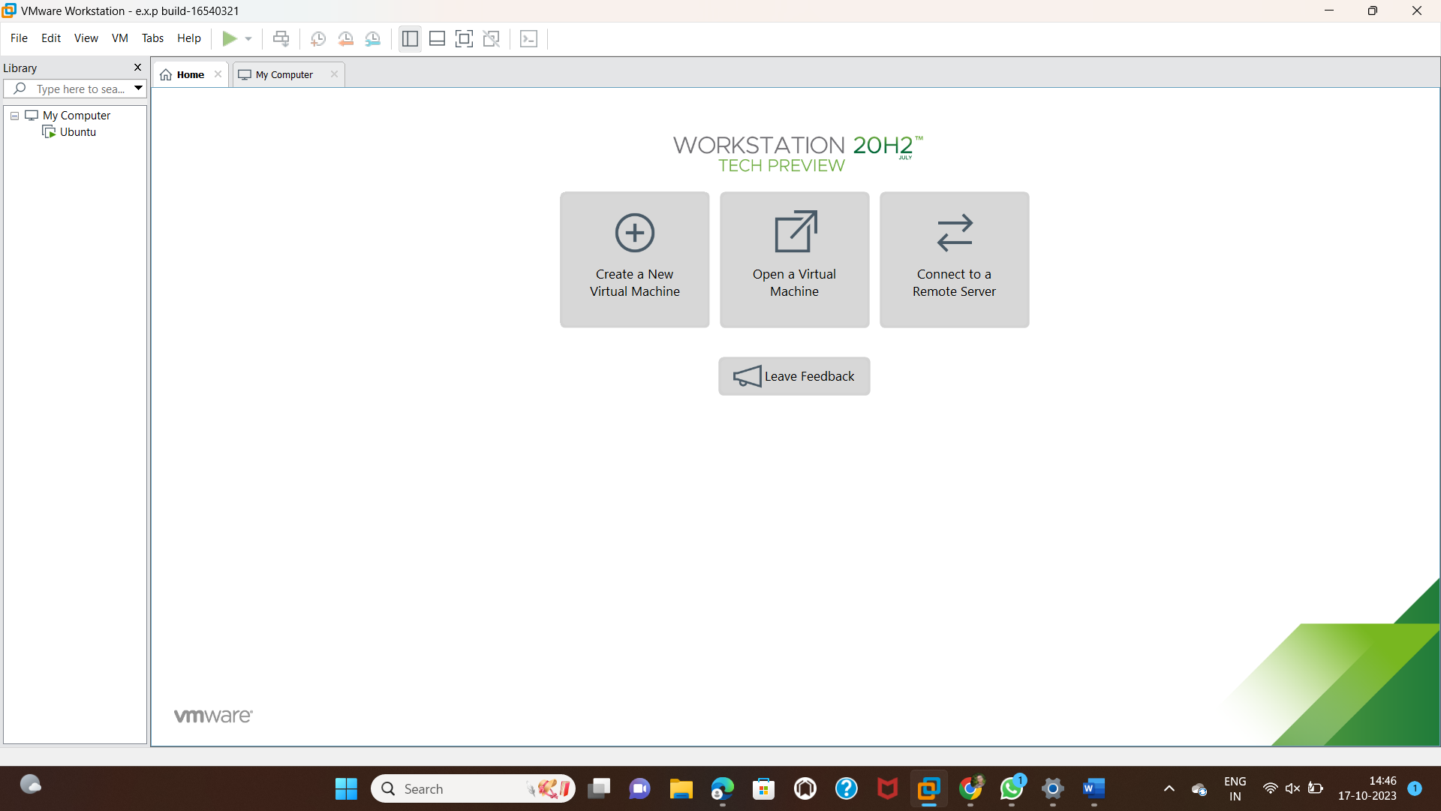

STEP2: DOWLOAD UBUNTU OR TINY OS AS ISO IMAGE FILE

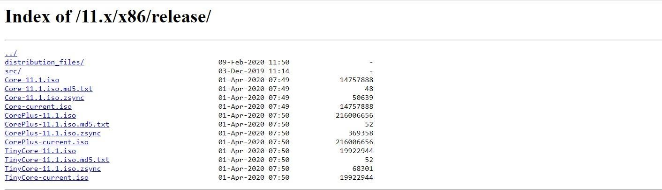

**STEP 3: IN VMWARE WORKSTATION->CREATE NEW VM**

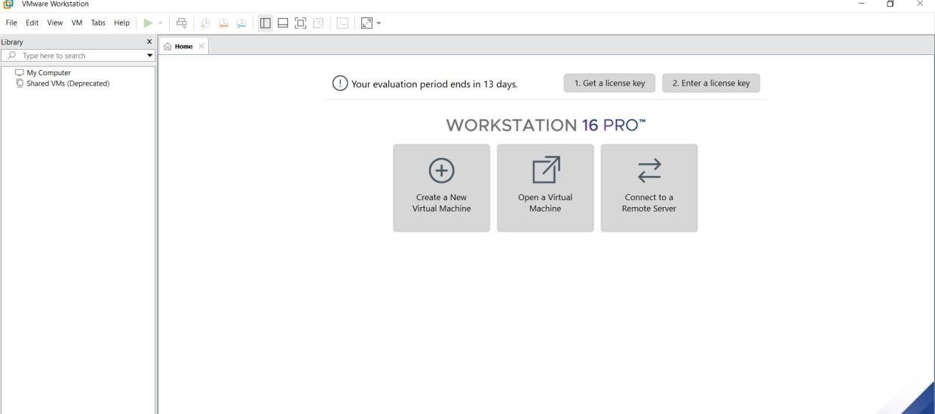

**STEP 4: DO THE BASIC CONFIGURATION SETTINGS.**

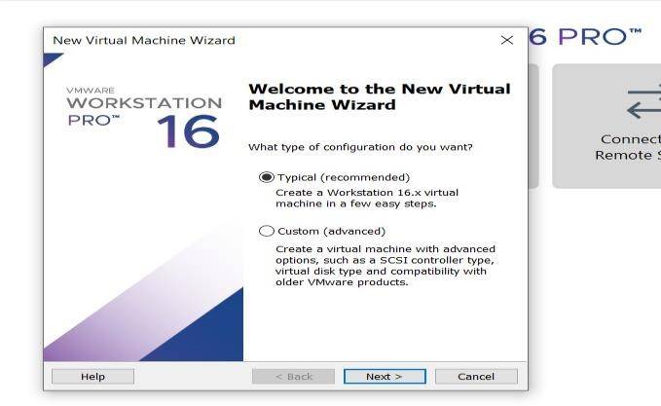

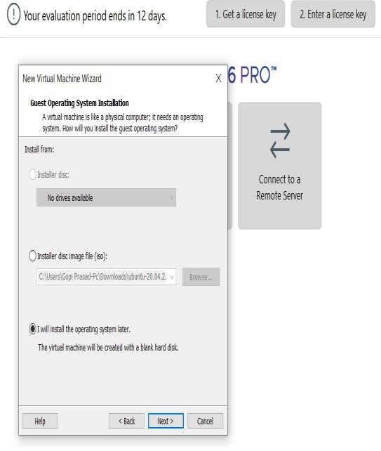

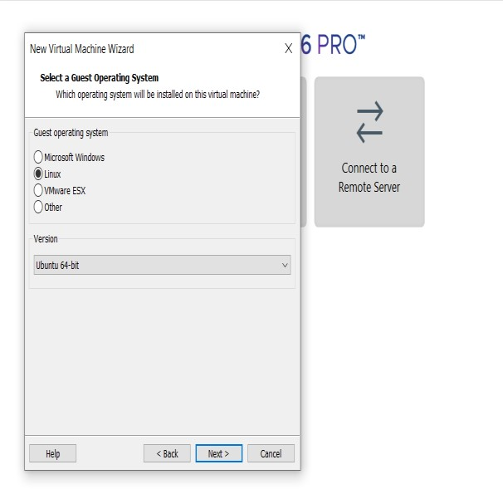

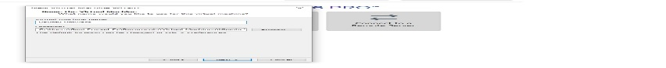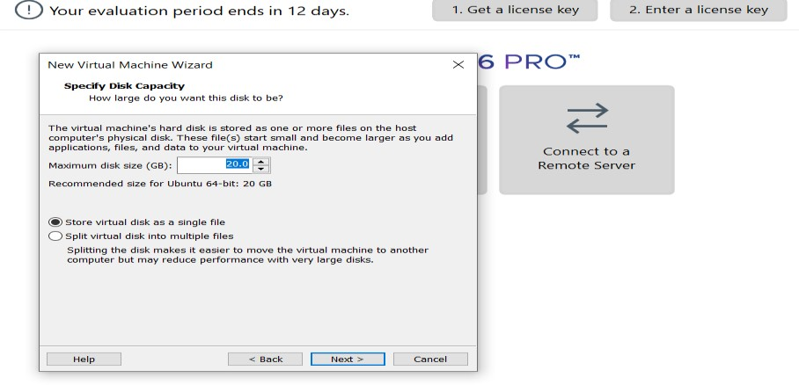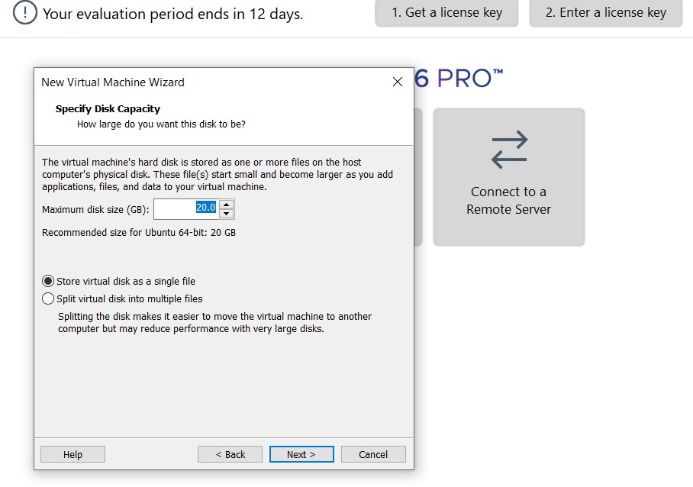

**STEP 5: CREATED TINYOS VIRTUAL MACHINE**

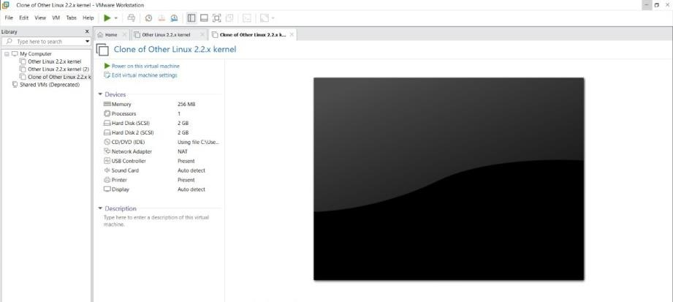

**STEP 6: LAUNCH THE VM**

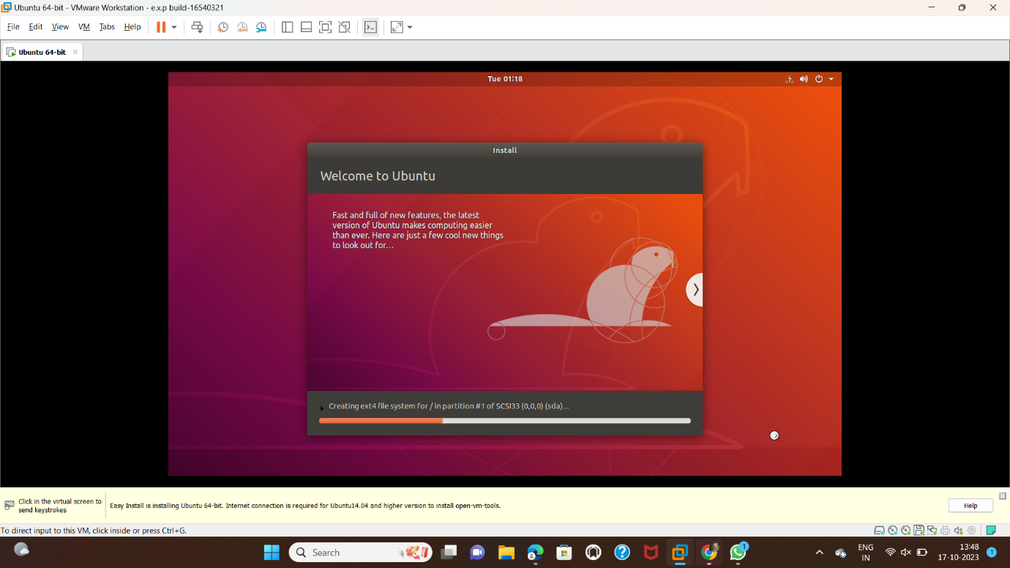

2. Create a Virtual Machine with 1 CPU, 2GB RAM and 15GB storage disk using a Type 2 Virtualization Software.

**AIM:**

To create a virtual machine with 1 cpu, 2gb ram and 15gb storage disk using a type 2 virtualization software**.**

**PROCEDURE:**

**STEP 1:**Dowload VMware workstation and installed as type 2 hypervisor.

**STEP2:**Dowload ubuntu or tiny OS as iso image file.

**STEP 3:** In VMware workstation->create new VM.

**STEP 4:** Do the basic configuration settings.

**STEP 5:** Created tiny OS virtual machine.

**STEP 6:** Launch the VM.

**STEP 1:DOWLOAD VMWARE WORKSTATION AND INSTALLED AS TYPE 2 HYPERVISOR**



**STEP2: DOWLOAD UBUNTU OR TINY OS AS ISO IMAGE FILE**



**STEP 3: IN VMWARE WORKSTATION->CREATE NEW VM**



**STEP 4: DO THE BASIC CONFIGURATION SETTINGS.**







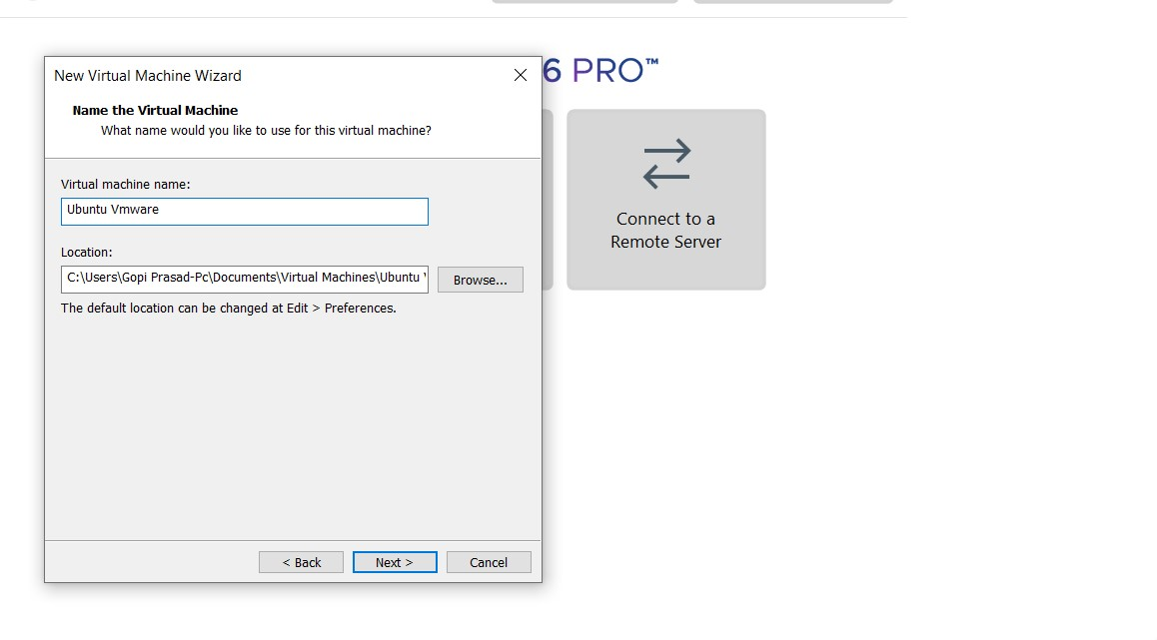

**STEP 5: CREATED TINYOS VIRTUAL MACHINE**

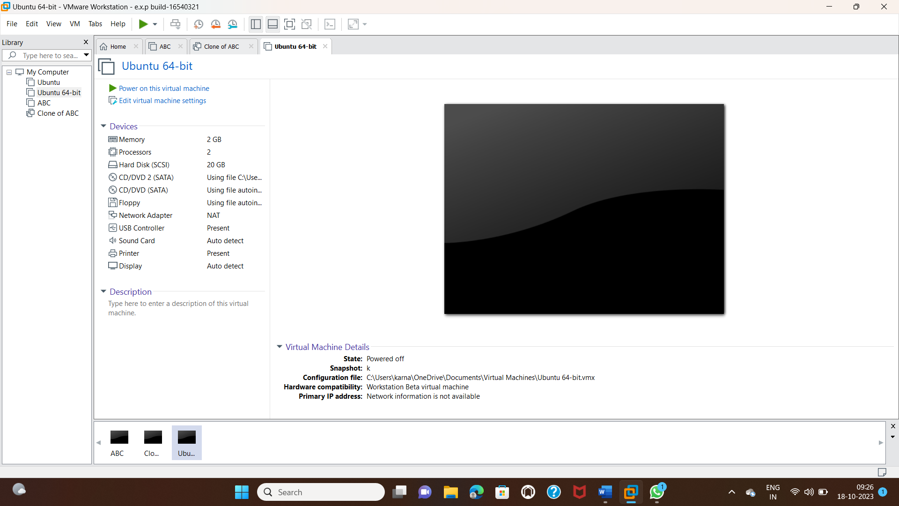

**3.CREATE A VIRTUAL HARD DISK AND ALLOCATE THE STORAGE USING VM WARE WORKSTATION.**

**AIM:**

To create a virtual hard disk and allocate the storage using vm ware workstation

**PROCEDURE:**

**STEP 1:**GOTO VM WARE WORKSTATION.

**STEP2:** RIGHT CLICK THE VM AND GOTO THE SETTINGS.

**STEP 3:** ADD HARDWARE WIZARD AND SELECT SCSI AND CLICK NEXT.

**STEP 4:** CREATE NEW VIRTUAL DISK.

**STEP 5:** SELCT THE DISK SIZE AS 2.0. AND SELCT SPLIT VIRTUAL DISK INTO MULTIFILES.

**STEP 6:** GIVE NAME AND CLICK THE FINISH.

**IMPLEMENTATION:**

**STEP 1:GOTO VM WARE WORKSTATION**

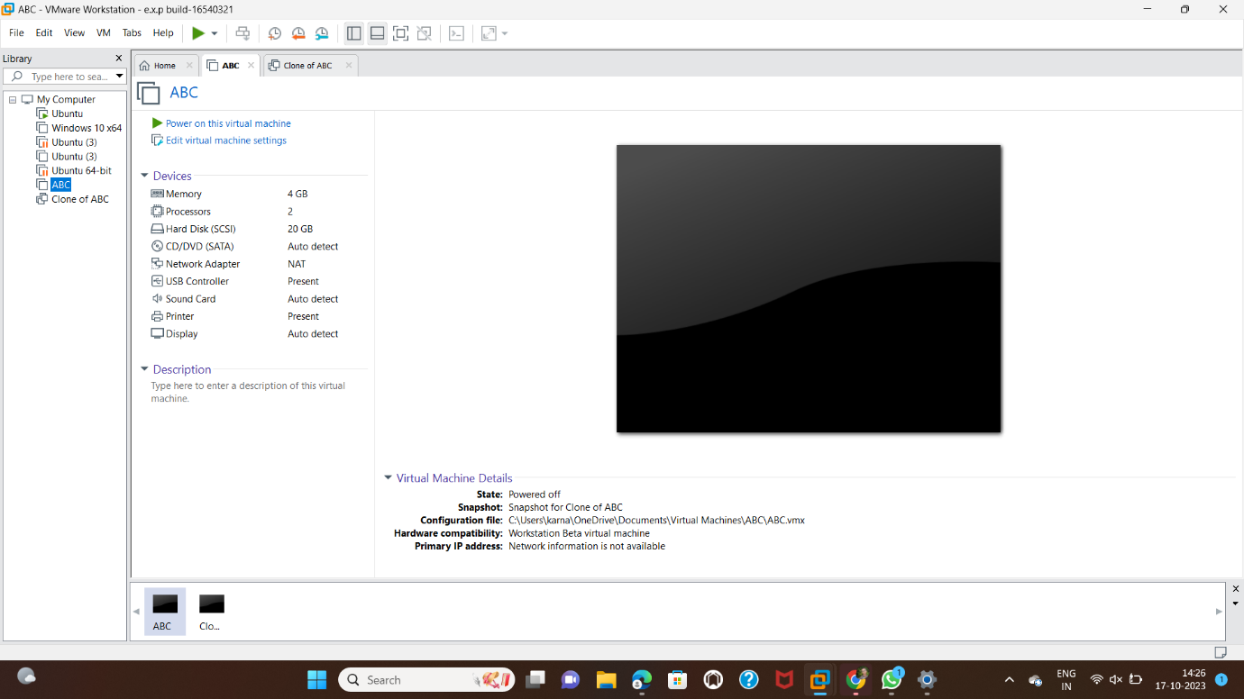

**STEP2: RIGHT CLICK THE VM AND GOTO THE SETTINGS**

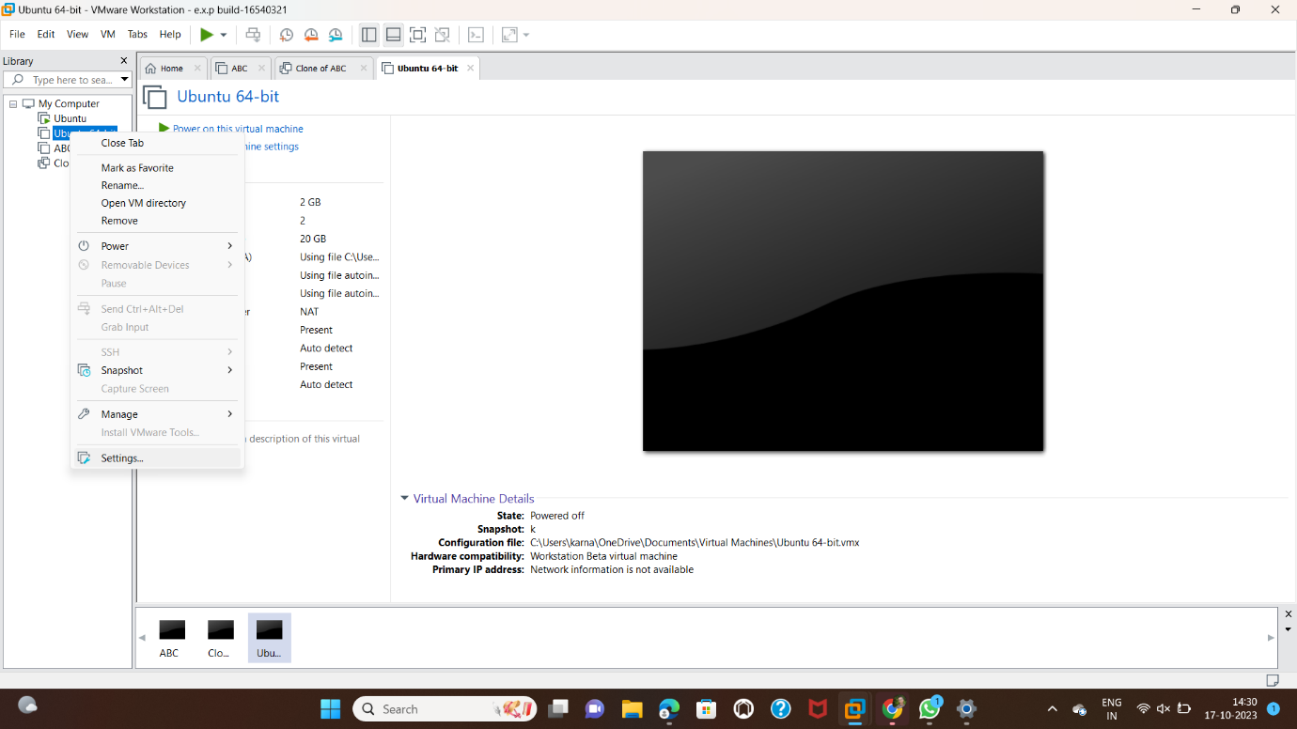

**STEP 3: ADD HARDWARE WIZARD AND SELECT SCSI AND CLICK NEXT**

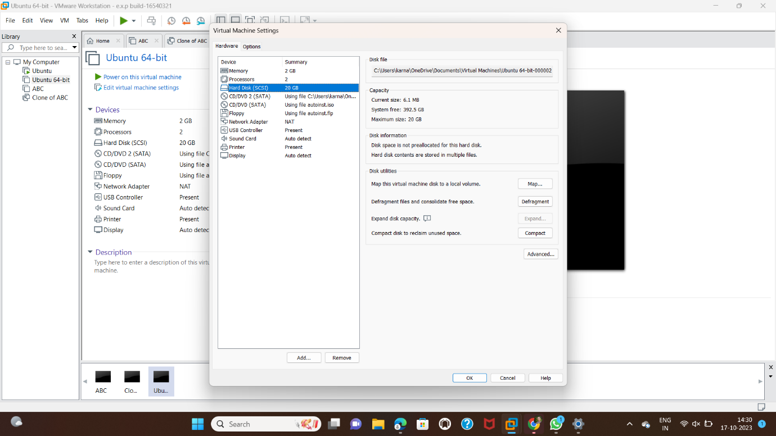

**STEP 4: CREATE NEW VIRTUAL DISK**

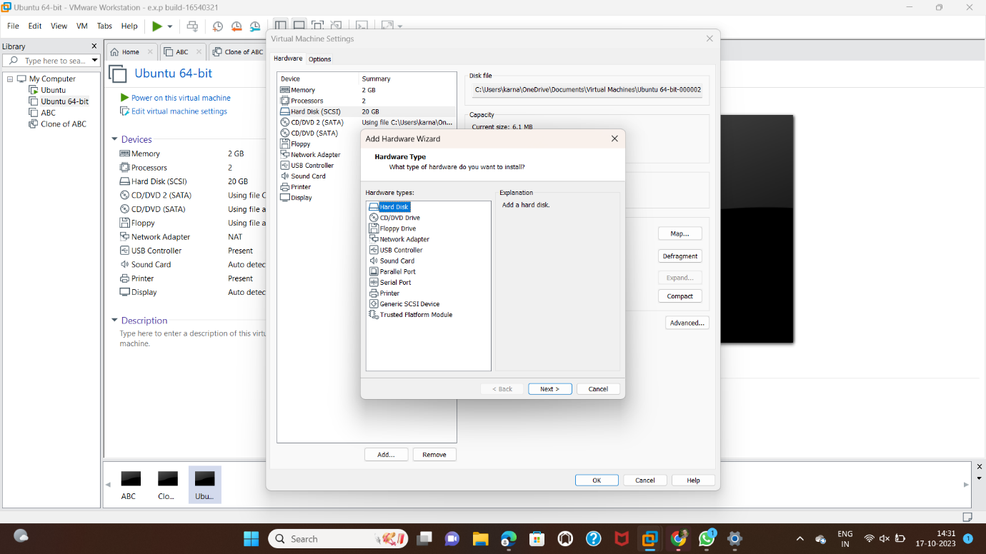

**STEP 5: SELCT THE DISK SIZE AS 2.0. AND SELCT SPLIT VIRTUAL DISK INTO MULTIFILES.**

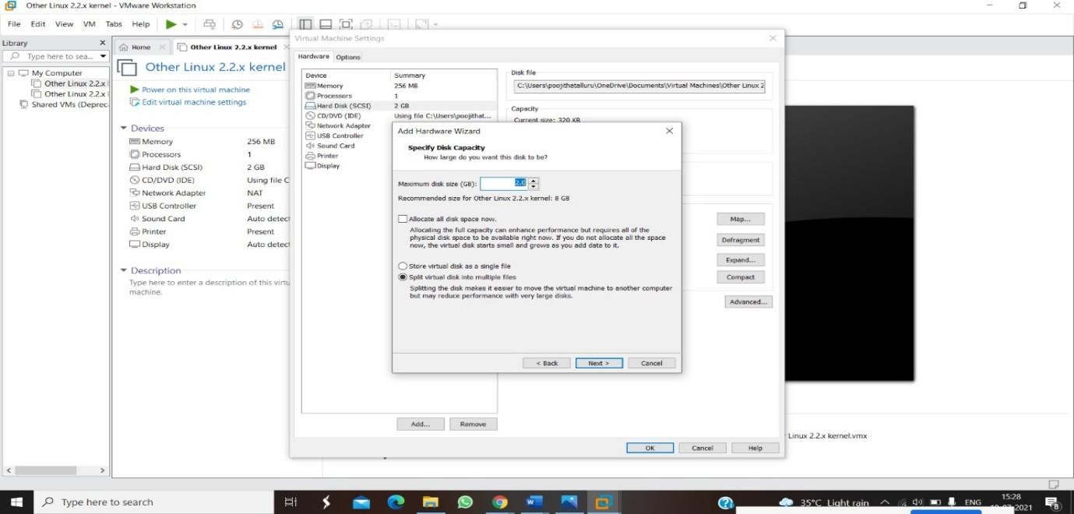

**STEP 6: GIVE NAME AND CLICK THE FINISH**

4. **CREATE A SNAPSHOT OF A VM AND TEST IT BY LOADING THE PREVIOUS VERSION/CLONED VM**

**AIM:**

To create a snapshot of a vm and test it by loading the previous version/cloned vm

**PROCEDURE:**

**STEP 1:** GOTO VMWARE WORKSTATION**.**

**STEP 2:** CREATE FILES ON DESKTOP.

**STEP 3**: CLICK ON VM AND SELECTS SNAPSHOT-> TAKE SNAPSHOT.

**STEP 4:** SNAPSHOT IS BEING DONE

**IMPLEMENTATION:**

**STEP 1: GOTO VMWARE WORKSTATION**

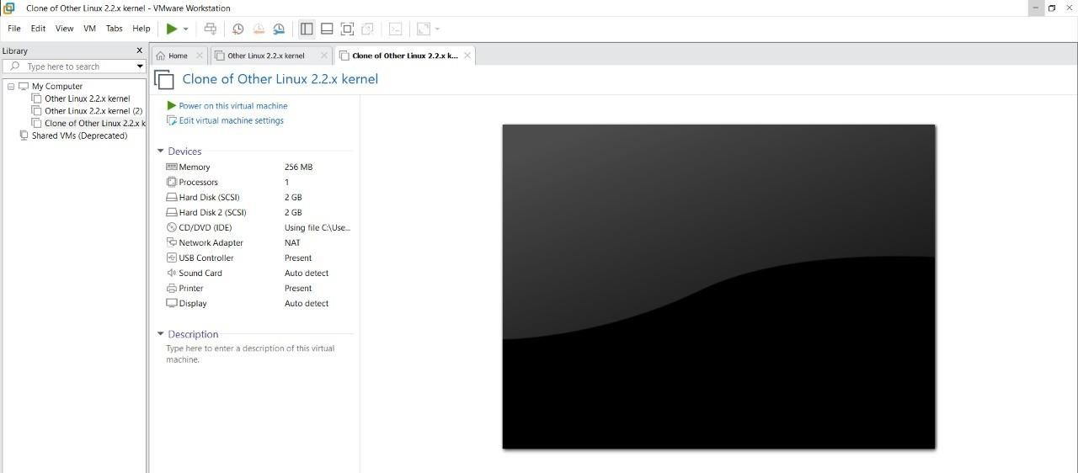

**STEP 2: CREATE FILES ON DESKTOP**

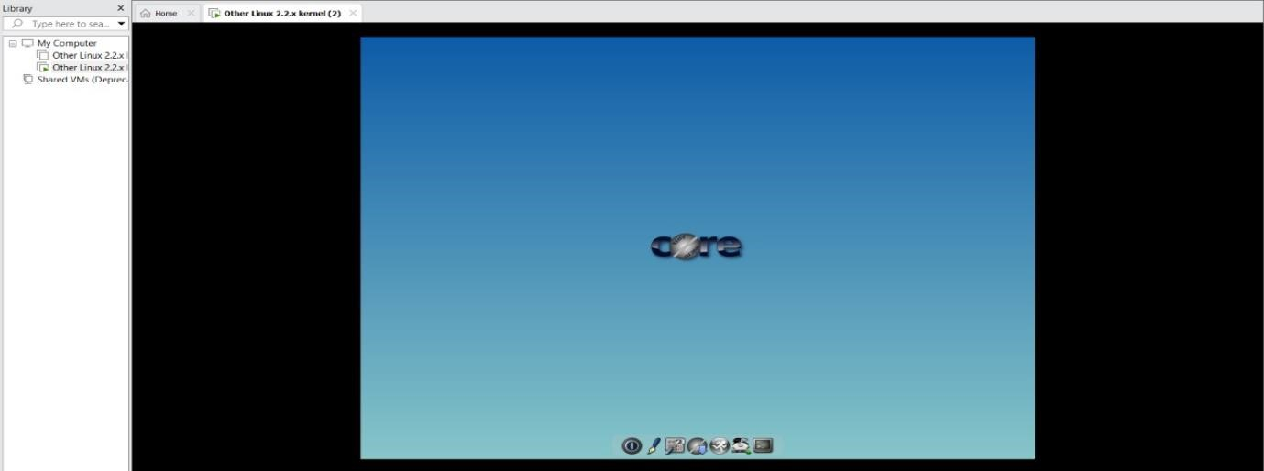

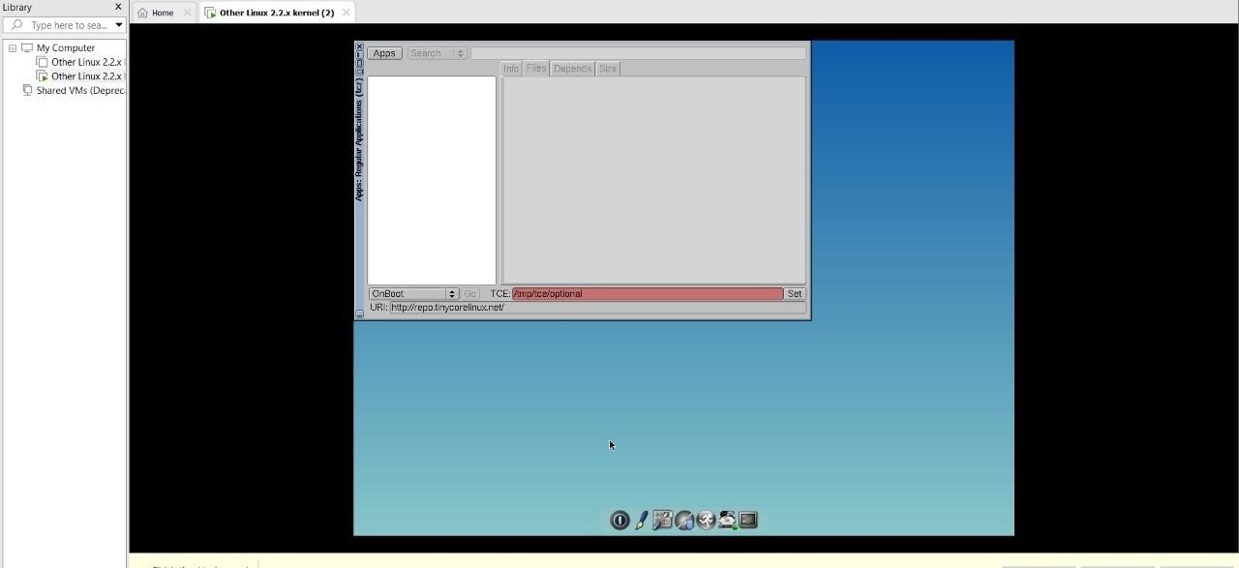

**STEP 3: CLICK ON VM AND SELECTS SNAPSHOT-> TAKE SNAPSHOT.**

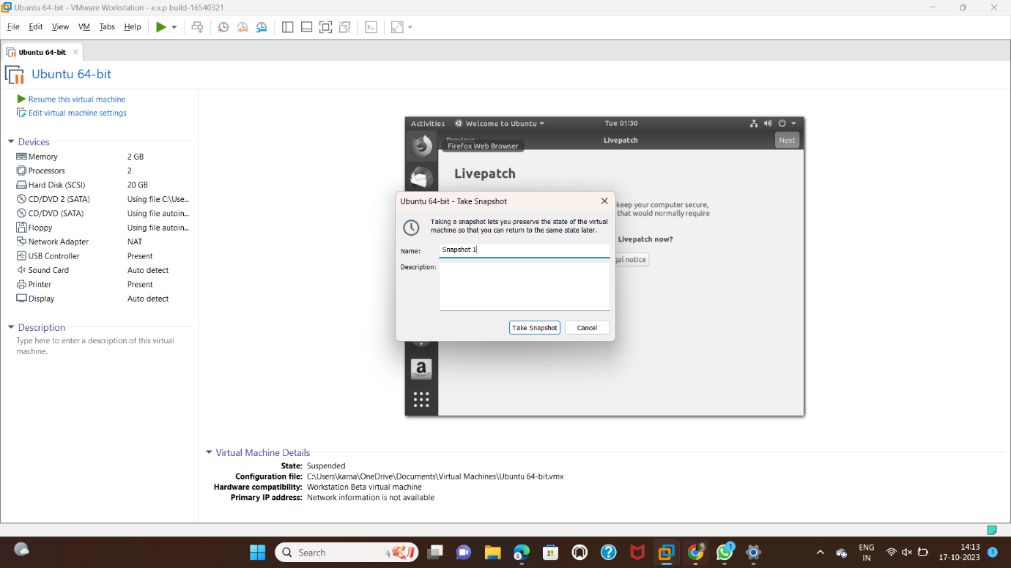

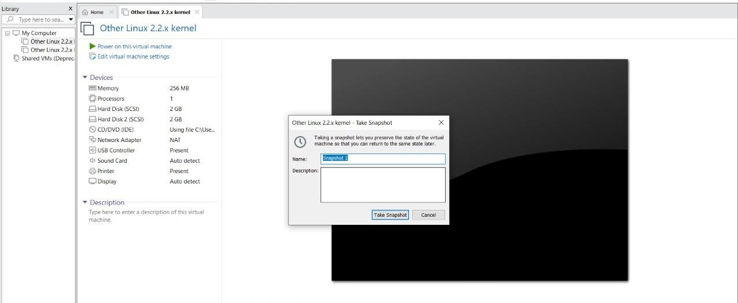

**STEP 4: SNAPSHOT IS BEING DONE**

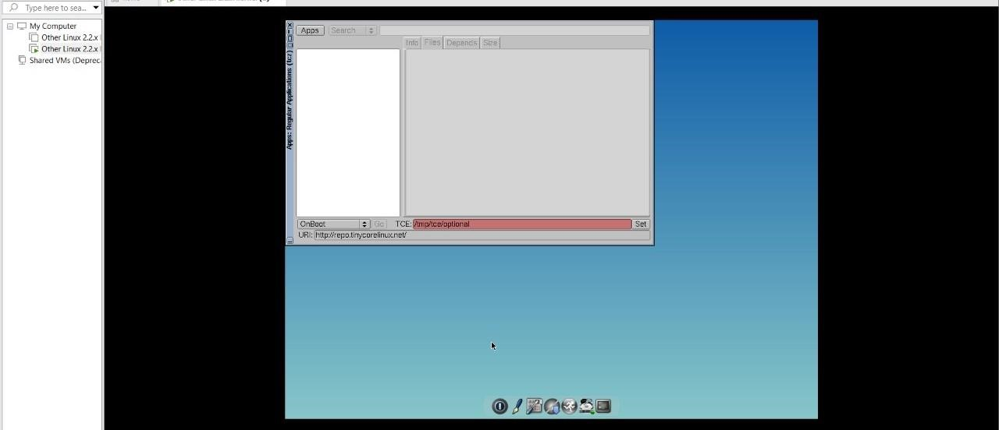

**5.CREATE A CLONING OF A VM AND TEST IT BY LOADING THE PREVIOUS VERSION/CLONED VM.**

**AIM:**  **PROCEDURE:**

**STEP 1**: GO TO VM AND GOTO MANAGE AND CLICK CLONE

**STEP 2:** CLICK CLONE

**STEP 3:** SELECT THE FULL CLONE

**STEP 4**: AFTER CLONE AGAIN OR VM IS OPENED.

**IMPLEMENTATION:**

**CLONING OF A VM**

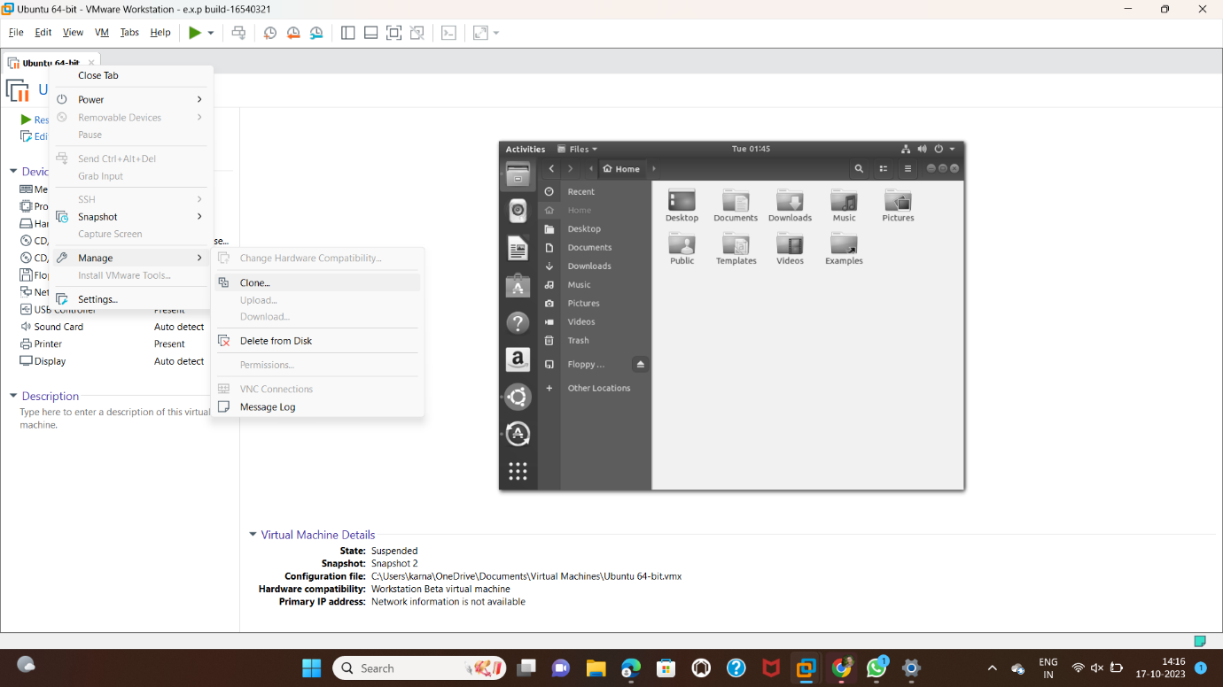

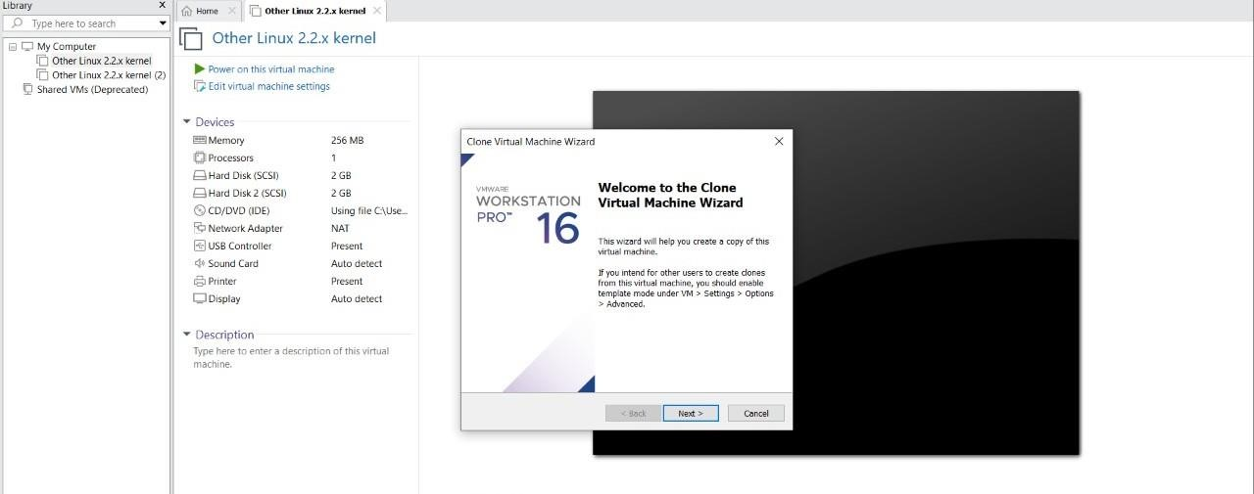

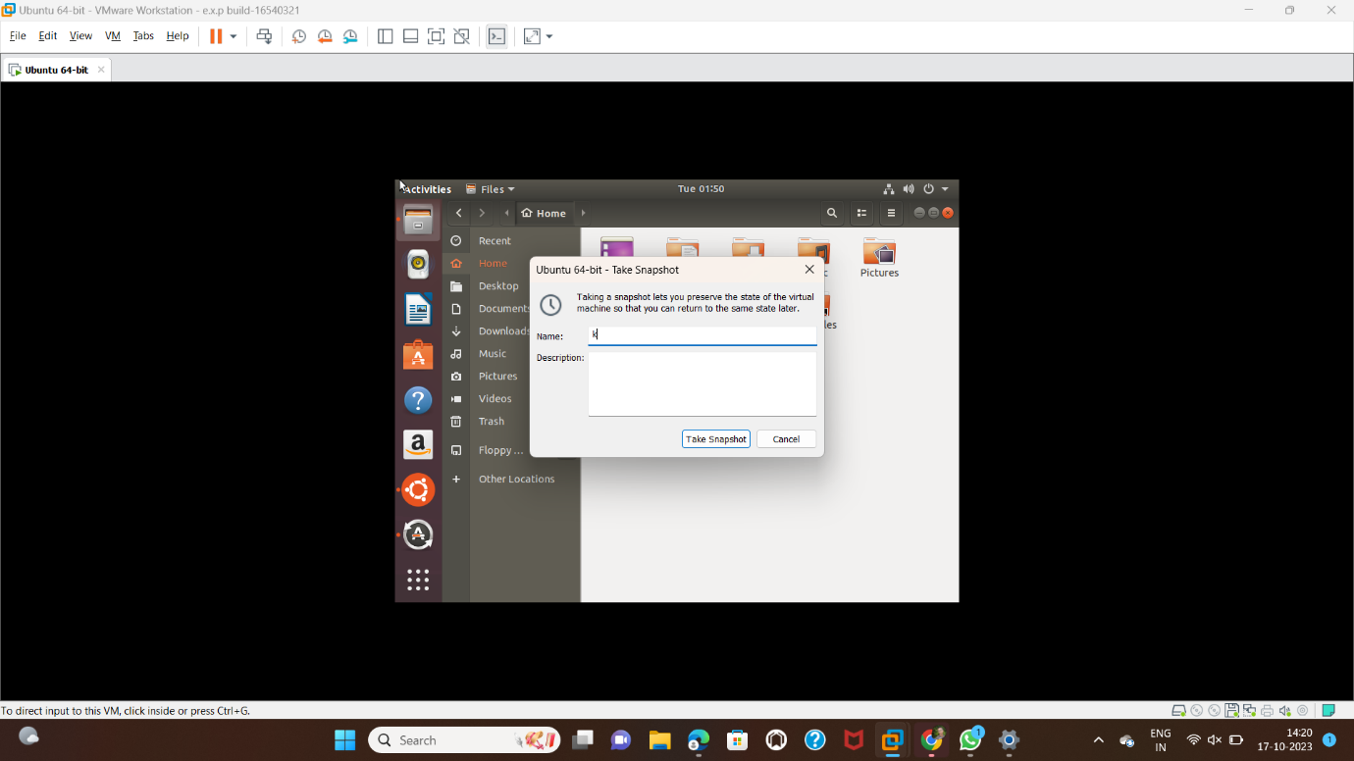s

